23.34: Energy is conserved:
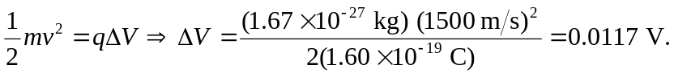
But:
